

2024

DSS Attrition Data Analysis

Done By:

Khaldoun Khyami 20210136

Faisal Belbeasi 20210225

Marwan Bostaji 20210528

Mohammad Yahya 20210527

Table of Contents

1 Report Objectives 4

2 Report Structure 4

3 Introduction 4

4 Demographic Factors Analysis 5

5 Subject related Factors Analysis 7

6 Job related factors analysis 9

7 Geographical factors analysis 16

8 Summary of Results and Recommendations 17

8.1 Predictions 19

8.2 Future Recommendations 19

Bibliography 21

Appendices 21

Appendix A: Reference of attrition data 21

Appendix B: Other Attrition Analysis 22

Table of Figures:

Figure 1: Analysis of employees’ marital status and attrition 5

Figure 2: Analysis of employees’ age 6

Figure 3: Analysis of employees’ work life balance with Environment satisfaction 7

Figure 4: Analysis of employees’ work life balance with Environment satisfaction 8

Figure 5: The analysis of employee’s monthly income 9

Figure 6: The analysis of employee’s numbers of companies work. 10

Figure 7: The analysis of employee’s educational field 11

Figure 8: The analysis of employee’s Job Satisfaction 12

Figure 9: The analysis of employee’s number of years worked 13

Figure 10: The analysis of employee’s distribution by departments 14

Figure 11: Analysis of employees’ work life balance 15

Figure 12: The analysis of employee’s distance from home 16

# 1 Report Objectives

This comprehensive report aims to investigate the impact of attrition within XYZ Company, exploring its correlation with various factors. This study analyzes the relationship between attrition and key variables. The analysis aims to unveil the correlation between attrition and these variables, shedding light on their influence on employee turnover within the organization. In the analysis, Excel and Colab Python were employed to process and analyze the provided data, as evidenced in Appendix B

# 2 Report Structure

The report on attrition analysis in company "XYZ" adopts a structured approach, commencing with an introductory section that provides a definition of attrition and outlines the overall objective of the analysis. The subsequent sections enumerate variables considered, encompassing demographic factors, job related factors, geographical factors, and subject related factors. The data analysis section employs statistical methods, offering insightful commentary, predictions, and correlations between these factors and attrition rates. Findings emphasize key correlations, and the report provides recommendations for strategic approaches based on the analysis. The conclusion briefly summarizes the main insights derived from the analysis. Additionally, the report concludes with recommendations for addressing attrition concerns within the company.

# 3 Introduction

The following document represents the data analysis of attritions in a company based on different variables. What is attrition? Attrition is the departure of employees from an organization concluded from any reason voluntary or involuntary. In this report we analyzed how several factors may or may not have a direct impact on attrition rates in company “XYZ” the factors taken into consideration are:

* Age
* Which department employee “x” works in
* How far is distance between employee “x”s home and workplace
* Number of degrees employee “x” has
* “x” education field
* How satisfied is employee “x” in the workplace environment
* How satisfied is employee “x” with his job
* “x” marital status
* Monthly income of employee “x”
* Number of previous company’s employee “x” worked in
* “x”s work life balance
* How many years has “x” employee been with the companyTop of Form

# 4 Demographic Factors Analysis

This chapter focuses on analyzing the demographic profile of employees and exploring the factors that may influence attrition. The first analysis aims to examine the relationship between marital status with attrition rates.as shown in figure 1.

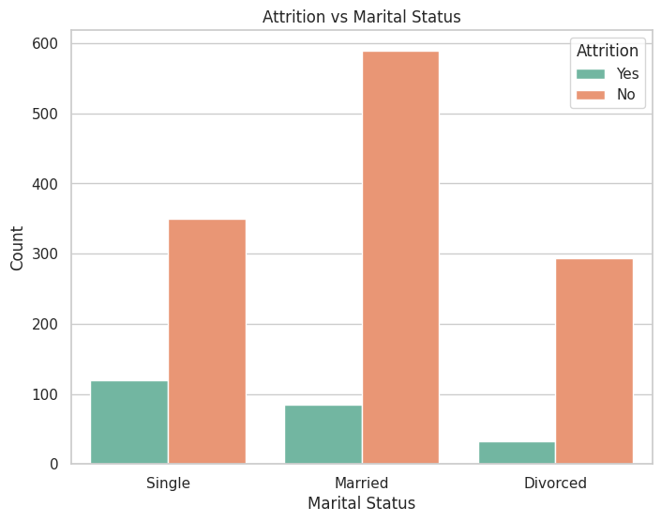

Figure 1: Analysis of employees’ marital status and attrition

The marital status segmented attrition analysis reveals interesting patterns. Among the groups, "Single" employees have the highest attrition rate, with 120 cases, indicating a higher likelihood of leaving than "Married" employees, who have a lower attrition count of 84. Meanwhile, the Divorced" group has the lowest attrition rate of 33, indicating that this category has a higher retention rate as shown in figure 1.

Figure 2: Analysis of employees’ age

The bar chart shows the attrition rates for various age groups reveals some interesting patterns. Notably, the age group of 18 to 30 has the highest attrition rate, followed by the age group of 31 to 45, and the age group of 46 to 60 has the lowest attrition. This pattern highlights a significant finding: compared to their older counterparts, younger employees—especially those in the 18–30 age range—are more likely to leave the company.

# 5 Subject related Factors Analysis

Following the identification of employees' demographic factors, the subsequent section centers on the subject related aspects related to attrition. Several professional comparisons have been conducted, considering the available attributes. The initial analysis specifically explores a comparison between worklifebalanace and enivtromnet satsifaction by attrutoin

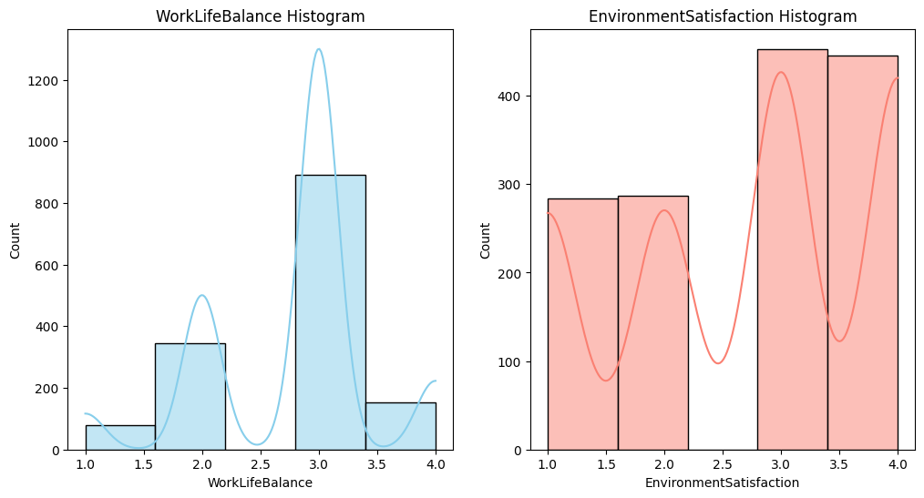

Figure 3: Analysis of employees’ work life balance with Environment satisfaction

The histogram shows correlation coefficient between work-life balance and environment satisfaction is 0.46, indicating a moderate positive correlation. This suggests that there is a tendency for individuals who rate their work-life balance higher to also rate their environment satisfaction higher, while there is a positive correlation between work-life balance and environment satisfaction, It's crucial to remember that a correlation does not indicate a cause. In order to raise employee satisfaction levels overall, organizations should concentrate on programs that improve environmental aspects and work-life balance.

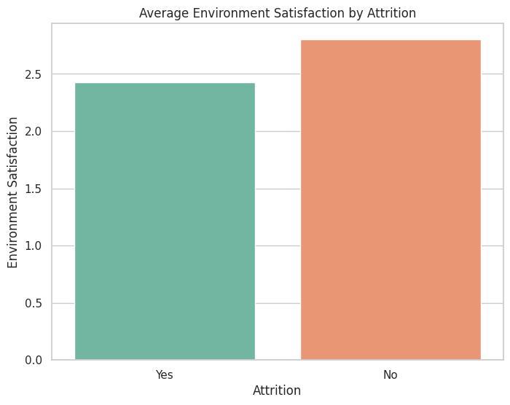

Figure 4: Analysis of employees’ work life balance with Environment satisfaction

The bar chart visually demonstrates the relationship between attrition and environment satisfaction, making it clear that environment satisfaction has an effect on the attrition of employees. The data suggests a potential relationship between attrition and environmental satisfaction. Further statistical analysis is needed to confirm the significance of this relationship. Employees who left the company tend to have lower average environmental satisfaction compared to those who stayed. Understanding the factors contributing to lower satisfaction levels can help in implementing targeted improvements to retain valuable employees. It is essential to consider additional variables or factors (such as job role, work-life balance, etc.) to provide a comprehensive analysis and actionable insights.

# 6 Job related factors analysis

After identifying the subject related factors of the employees, the fifth section focused on analyzing the job related factors. Figure shows the analysis of attrition and monthly income.

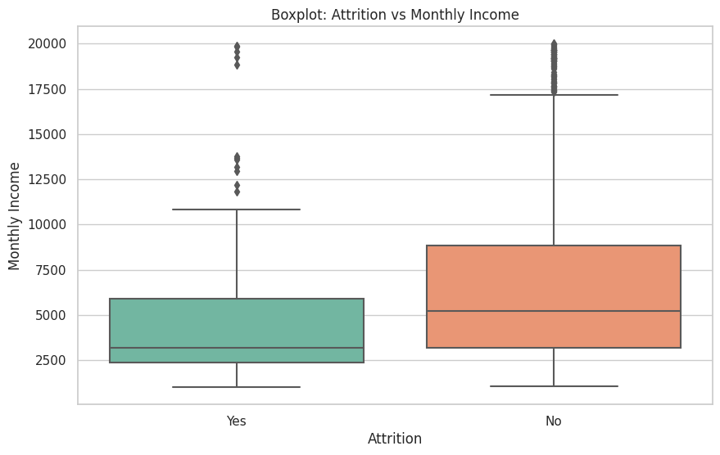

Figure 5: The analysis of employee’s monthly income

The analysis of monthly income distribution among employees with and without attrition reveals distinct patterns. For the "No" group (no attrition), the median monthly income is $5,000, with a broad interquartile range from $3,500 to $7,000. This group exhibits a wide distribution, indicating diverse income levels, and some outliers contribute to the higher range, with a maximum value of $10,000. In contrast, the "Yes" group (attrition) shows a lower median monthly income of $4,000, and a more compact interquartile range from $3,000 to $5,000, suggesting less variability in monthly incomes for departing employees. However, there are outliers with higher incomes, reaching a maximum of $8,000.

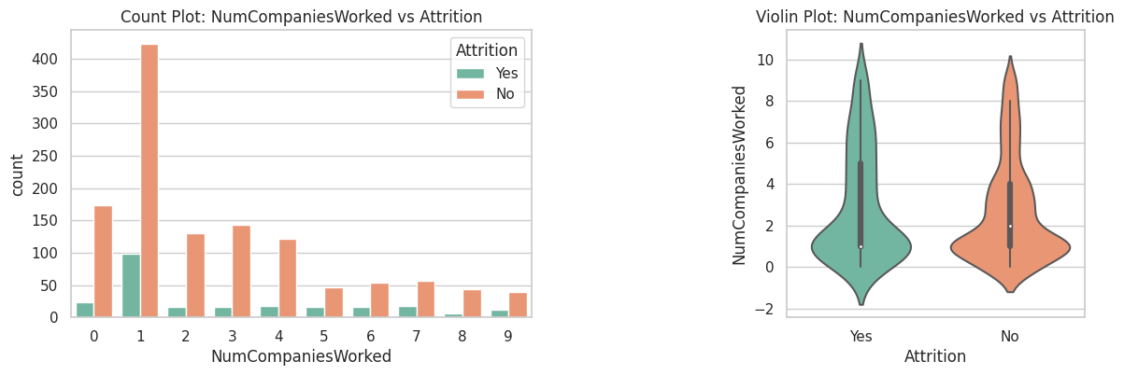

Figure 6: The analysis of employee’s numbers of companies work.

The analysis found to identify attrition patterns in the dataset's Number of Companies Worked. The total number of attrition was 237 people. Individuals associated with working for one company had the highest attrition rate, with 98 departures. Those with 0 years of experience were closely followed by those with 23 cases of attrition. Furthermore, attrition rates for individuals with work experience in 2, 3, 4, 5, 6, 7, 8, and 9 companies were 16, 16, 17, 16, 16, 17, 6, and 12, respectively. The visualization, which was represented by a violin chart, successfully showed these attrition trends across a variety of company sizes. These findings point to possible links between work experience and attrition rates.

Figure 7: The analysis of employee’s educational field

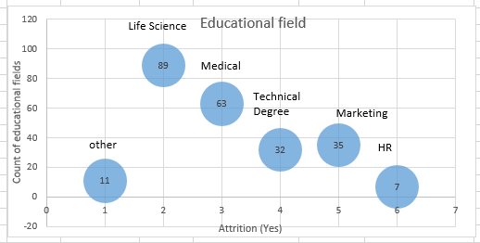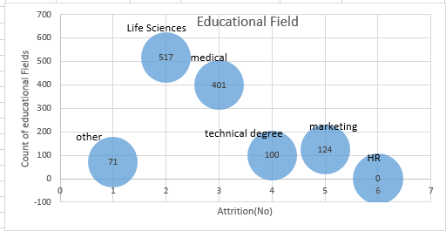

The analysis of attrition patterns across various educational fields within the dataset revealed a total attrition count of 239 individuals. Among these, Life Sciences had the highest attrition rate, with 11 people leaving the field. Medical and technical degrees came in second and third, with 63 and 32 attritions, respectively. Furthermore, attrition rates in the Marketing, Other, and Human Resources fields were 35, 11, and 7, respectively. The visualization, which was presented as a bubble chart, provided a comprehensive overview of attrition trends, highlighting differences in attrition rates across these educational fields. These findings highlight the importance of developing adapted approaches to retention for specific educational categories in order to effectively reduce attrition rates.

Figure 8: The analysis of employee’s Job Satisfaction

The aim of the analysis is to comprehend attrition trends among the dataset's different Job Satisfaction levels. There were 237 people who were lost in total. With 66 departures, those with a Job Satisfaction 4 reported the highest attrition rate of all. Job Satisfaction 2 recorded 73 departures, closely followed by Job Satisfaction 3's 46 attrition cases. 52 cases of attrition were reported for Job Satisfaction 1. These attrition trends across various Job Satisfaction levels were effectively visualized through the use of a bar chart. These findings highlight the possible relationship between job satisfaction and attrition rates

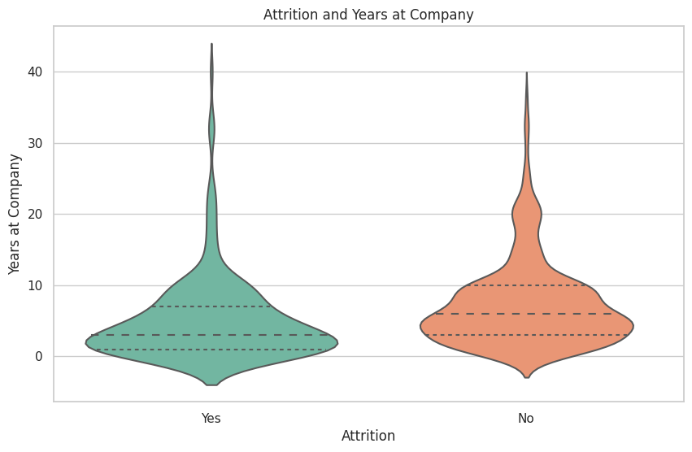

Figure 9: The analysis of employee’s number of years worked

The chart shows the distribution of time among employees, differentiating between those who were affected by attrition and those who were not. For attrition-affected employees, the minimum number of years of service is 0–40, with 0 serving as the minimum and 40 as the maximum. The distribution is fairly split up suggesting that different levels of tenure are held by employees who leave the company. Employees who do not experience attrition, on the other hand, exhibit a more concentrated distribution, with a minimum of 0 and a maximum of 40. This group's distribution seems to be concentrated in the 5–10-year range, and many of the employees have worked there for at least that long.

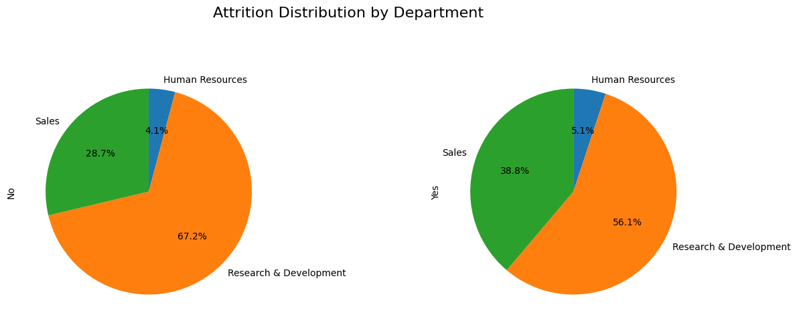

Figure 10: The analysis of employee’s distribution by departments

The pie chart illustrates the distribution of attrition among different departments within the company. Notably, the Research and Development (R&D) department has the largest share of employees experiencing attrition, constituting 56.1% of the total. Sales follows with 38.8%, and Human Resources accounts for 5.1% of attrition cases. On the other hand, for employees without attrition, R&D again leads with 67.2%, followed by Sales at 28.7%, and Human Resources at 4.1%. This visual representation provides a clear overview of attrition patterns across departments, offering valuable insights for strategic decision-making

Figure 11: Analysis of employees’ work life balance

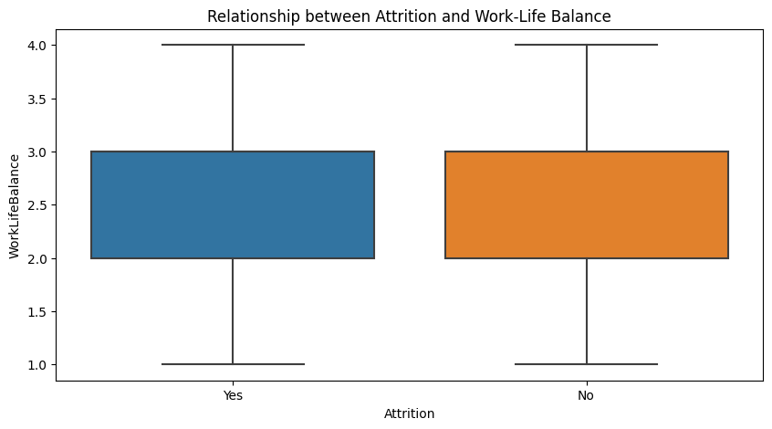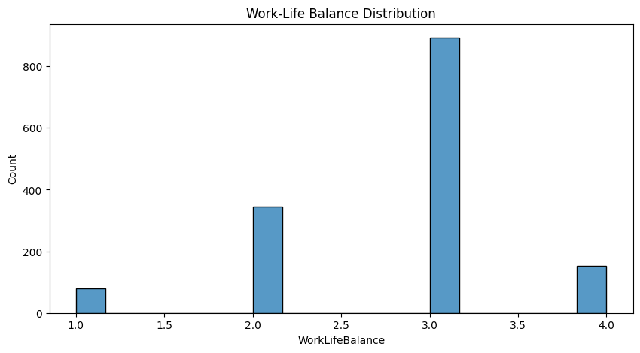

The analysis shows a significant number of employees have not experienced attrition ("No") based on the frequency count. The distribution of work-life balance scores can help assess the overall work-life balance within the organization. The boxplot can provide insights into whether there's a correlation between work-life balance and attrition. For instance, if employees with lower work-life balance scores are more likely to experience attrition**.**

# 7 Geographical factors analysis

In this part we are analyzing Attrition rates based on the distance of the company to the employee’s home. We divided the distances into 4 intervals as shown in the figure, based on this we can study and analyze reasons for these attritions according to the employee’s distance from home.

Figure : The analysis of employee’s distance from home

The line chart shows there are higher than average attrition rates in the 1-7 mile and 8-14 mile categories for both the "Yes" and "No" attrition groups. Interestingly, workers who live closer to the office—between one and fourteen miles away—have higher attrition rates. This could be due to a variety of factors, including the stress of commuting, traffic, or the expense of living close to the office. Furthermore, the data displays a consistent trend in the 15–29-mile range, suggesting that, after a certain point, distance might not be a significant factor in attrition. This realization implies that as one gets farther away from the place of employment, variables other than proximity become more significant in figuring out attrition patterns.

# 8 Summary of Results and Recommendations

This study leveraged data analysis techniques, primarily utilizing Python programming language, excel and data visualization libraries. The analysis focused on understanding patterns and associations related to employee attrition within a given dataset.

Interestingly, "Single" employees have the highest attrition rate—120 cases—which suggests that they are more likely to leave than their "Married" counterparts, who have a lower attrition count of 84. The "Divorced" group, on the other hand, shows the lowest attrition rate of 33, indicating a higher retention rate in this category. The analysis that focuses on various age groups reveals unique trends. In particular, the highest rates of attrition are found in the 18–30 age group, which is followed by the 31–45 age group, and the lowest rates are found in the 46–60 age group. This highlights a noteworthy trend: younger workers—especially those between the ages of 18 and 30—have a higher turnover rate than their more experienced counterparts.

Additional research reveals differences across fields in attrition based on educational backgrounds. With 11 people leaving the field, life sciences have the highest attrition rate. Following closely behind 63 and 32 attritions, respectively, are degrees in medicine and technology. Other fields with attrition rates of 35, 11, and 7 are Marketing, Other, and Human Resources, respectively. According to the analysis of job satisfaction levels, those who report the highest attrition rate—66 departures—have a satisfaction level of 4. Those with a satisfaction level of 2, who recorded 73 departures, are closely behind this. On the other hand, 52 attrition cases are reported by those with satisfaction level 1. The analysis of tenure distribution between attrition-affected and non-attrition employees reveals a more diverse distribution among the former. while non-attrition cases display a concentrated distribution, particularly in the 5–10-year range.

 Further analysis based on the number of companies worked for reveals that employees affiliated with a single company have the highest attrition rate (98 departures). Effective visualization is used to show patterns across different company sizes. This diagram shows how attrition is distributed across the company's departments. Remarkably, of all the departments, the Research and Development (R&D) department has the highest percentage of attrition—56.1%. Sales arrives in second with 38.8%, while 5.1% of attrition cases are related to human resources. Higher attrition rates are observed in the 1–7 and 8–14 mile categories, according to the analysis that focuses on proximity to the workplace. Higher attrition rates are linked to living one to fourteen miles closer to the office. This could be related to things like stress from the commute, traffic, or the cost of living near the office. Additionally, the data displays a consistent trend in the 15–29-mile range, suggesting that, beyond a certain point, distance may not significantly impact attrition.

On the other hand, the analysis shows that there is a moderately positive correlation (r=0.46) between work-life balance and environment satisfaction. This suggests that people who are more satisfied with their work-life balance are also more likely to be satisfied with their surroundings.

Based on frequency count, a significant number of employees have not experienced attrition. The distribution of work-life balance scores suggests further investigation, with a boxplot used to investigate potential correlations between work-life balance and attrition. This method provides a deeper awareness of how work-life balance scores are distributed among employees who have experienced attrition or not.

The relationship between environment satisfaction and attrition is graphically represented by the bar chart. Remarkably, average environmental satisfaction tends to be lower among departing employees than among remaining ones. Although this suggests that attrition and environmental satisfaction may be related, it is stressed that more statistical research is required to confirm the significance of this relationship.

It is vital to take into account extra variables, such as work-life balance, job roles, and other relevant factors, in order to improve the analysis. This all-encompassing strategy guarantees a more nuanced comprehension of the elements influencing employee satisfaction and attrition, offering a strong basis for practical insights. To sum up, the data emphasizes how crucial it is to carry out comprehensive statistical analyses and take into account a variety of variables in order to obtain insightful knowledge for enhancing overall employee satisfaction and retention strategies.

In conclusion, this study used data analysis methods to examine trends and correlations regarding employee attrition in a particular dataset. These methods mainly involved the use of Excel, data visualization libraries, and the Python programming language. Interestingly, the highest attrition rate is found among single employees, especially in the 18–30 age range. Differences in attrition according to educational backgrounds and job satisfaction levels are further insights. In-depth examination of departmental attrition rates, tenure distribution, company affiliations, and proximity to the workplace are also included in the analysis. The relationship between work-life balance and environment satisfaction is found to be somewhat positive. The results emphasize that in order to improve employee satisfaction and retention strategies, a thorough approach that takes into account factors like work-life balance and job roles is required. The information emphasizes how crucial comprehensive statistical analyses are to obtaining insightful information.

## 8.1 Predictions

* Taking into account the present trend, the business should exercise caution when adding a significant number of workers in the 18–30 age range. This group is more likely to attrition, according to historical data, which highlights the significance of addressing elements like work-life balance, career growth opportunities, and job satisfaction to reduce the risk of turnover.
* The Research and Development (R&D) department may continue to have higher attrition than other departments based on past attrition rates. On the other hand, it is anticipated that attrition in human resources will stay mostly stable. These forecasts emphasize that in order to maintain project continuity, innovation, and knowledge retention.
* Experience retention, innovation, and project continuity are all restricted by the expectedly high attrition in R&D. In order to address this, the business should concentrate on putting strategies like mentorship, professional development, and a friendly work environment into place in order to keep valuable talent in the department. On the other hand, Human Resources' low attrition offers stability and makes it possible to implement consistent HR policies and procedures for a productive and harmonious workplace.

## 8.2 Future Recommendations

* Provide onboarding and support for employees with no prior work experience to improve retention. For those with experience in one company, offer pathways for career advancement and professional growth within the organization.
* Implement specialized retention strategies for employees in high-attrition fields like Life Sciences. Create mentorship programs and targeted development opportunities to enhance engagement and commitment.
* Assess job satisfaction factors: Conduct regular surveys or assessments to understand factors influencing job satisfaction. Addressing issues related to career growth opportunities, work-life balance, and overall job satisfaction can significantly contribute to employee retention
* For departments with high attrition, conduct detailed exit interviews to identify specific concerns. Implement targeted retention strategies, such as mentorship programs or skills development initiatives.
* Conduct a gender-specific analysis to identify and address unique challenges. Implement initiatives to promote gender equality in career growth opportunities and address factors contributing to performance variations.
* Evaluate the feasibility of remote work options and flexible scheduling to accommodate employees with longer commutes. Consider providing resources or benefits to ease the challenges associated with longer distances.
* Implement programs to enhance employee engagement, satisfaction, and well-being, focusing on those living within 1-14 miles.
* Introduce flexible work hours or remote work options to reduce the burden of commuting, especially for employees living close to the office.
* Provide transportation benefits, subsidies, or solutions for employees with longer commutes to ease their travel-related challenges.
* Implement retention strategies specifically targeted at younger employees, such as mentorship programs, career development opportunities, and flexible work arrangements.
* Conduct exit interviews for employees leaving in the 18-30 age group to understand the reasons behind attrition and make improvements accordingly.
* Invest in training and development programs to enhance the skills and competencies of employees in the 18-30 age group, making them more valuable to the company.
* Focus on creating a positive and engaging work environment for all age groups. Regular feedback sessions and recognition programs can contribute to higher job satisfaction.
* Develop succession plans for key positions, especially in the 31-45 age group, to ensure a smooth transition and reduce the impact of unexpected departures.
* Assess and improve work-life balance policies, as this may be a factor influencing attrition in the younger age group.

# Bibliography

Waskom, M. (2021). seaborn: statistical data visualization. Journal of Open Source Software, 6(60), 3021. https://doi.org/10.21105/joss.03021

Hunter, J. D. (2007). Matplotlib: A 2D graphics environment. Computing in Science & Engineering, 9(3), 90–95. <https://doi.org/10.1109/MCSE.2007.55>

Wes McKinney. (2011). pandas: a foundational Python library for data analysis and statistics. Journal of Open Source Software, 6(60), 2979. <https://doi.org/10.21105/joss.02979>

The analysis of attrition data was conducted using Microsoft Excel (Microsoft Corporation, Redmond, WA).

# Appendices

## Appendix A: Reference of attrition data

The data set, which consists of 1471 rows and 13 columns, includes the following: age, department, marital status, educational field, work satisfaction, monthly income, distance from home, work-life balance, number of companies worked for, education, and finally, years at the company. That is provided by our professor

## Appendix B: Other Attrition Analysis

